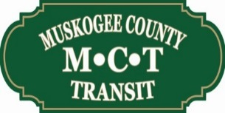
Muskogee County Public Transit Authority
4401 E. Hayes Street
Muskogee, Oklahoma 74403
February 16, 2021 — 4:00 p.m.

- Call Meeting to Order
- Roll Call
- Review meeting minutes from January 19, 2021, take action as necessary.
- Presentation of Financial Statements for January.
- Presentation of Directors Report.
- Presentation by Clint Morgan for possible change in AVL tracking provider from Verizon Networkfleet to US Cellular, take action as necessary.
- Announcements:
- New Business
- Adjournment

